📊 EDA Report (Exploratory Data Analysis)

Data modelling
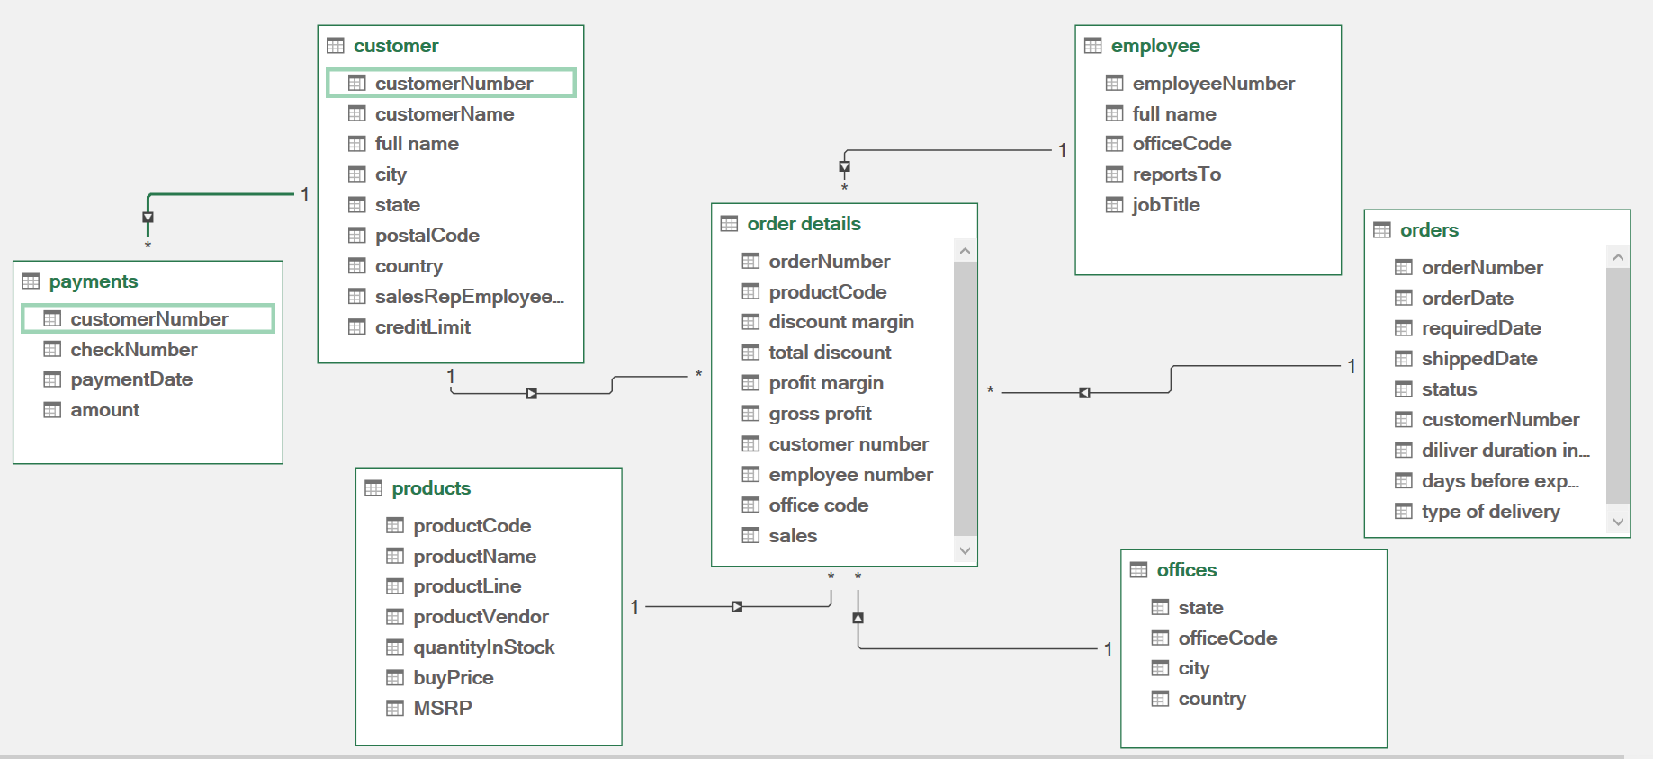

Note: this is the outcome after data pre processing
1. Project Overview
This dataset represents a B2B automobile parts business that:
- Procures parts from vendors
- Processes them into finished goods
- Sells to other businesses (clients)
The dataset contains transactional, customer, product, and operational data from 2003–2005, involving:
- 122 customers
- 326 orders
- 999 order line items
- 110 products

2. Objectives of EDA
The primary goals of this analysis are:
- Understand data structure and relationships
- Identify data quality issues
- Discover patterns in sales, customers, and products
- Define derived metrics for dashboards
- Prepare data for ETL and modeling

3. Dataset Structure
Core Tables
Table Name | Description
Customer | Client information
Orders | Order-level data
Order Details | Line-item details
Products | Product catalog
Product Line | Product categorization
Payments | Payment transactions
Employee | Sales representatives
Office | Regional office data

4. Data Relationships
- Customer → Orders (1:M)
- Orders → Order Details (1:M)
- Products → Order Details (1:M)
- Customer → Payments (1:M)
- Employee → Customer (1:M)
- Office → Employee (1:M)
- Product Line → Products (1:M)

5. Initial Observations
5.1 Customer Data Issues
- Missing:
  - Email
  - Website
  - Acquisition channel
- No segmentation:
  - No loyalty classification
  - No customer tier (e.g., premium, standard)
- No behavioral metrics:
  - Last purchase date
  - Total orders
  - Customer lifetime value (CLV)

5.2 Orders & Transactions
- No explicit revenue column
- No shipping delay metric
- No order frequency tracking
- All data limited to 2003–2005 (static dataset)

5.3 Order Details Limitations
Missing important financial metrics:
- Discount
- Cost
- Profit margin

5.4 Payments Table Gaps
- No mapping to specific orders
- Cannot directly calculate:
  - Outstanding balance
  - Payment vs order linkage

5.5 Geographic Data Issues
- Inconsistent state/country naming
- Abbreviations used (hard for aggregation)

6. Data Cleaning Plan (Power Query)
Standardization
- Expand state/country abbreviations
- Normalize text fields (case, spacing)
Missing Data Handling
- Add placeholder columns:
  - Email
  - Website
  - Acquisition Channel
Derived Columns
- Order Count per Customer
- Last Order Date
- Total Revenue per Customer
- Shipping Delay:
Ship Date - Order Date

7. Feature Engineering
Customer-Level Features
- Total Orders
- Total Revenue
- Average Order Value (AOV)
- Last Purchase Date
- Customer Lifetime Value
- Customer Segment:
  - High Value
  - Medium Value
  - Low Value

Order-Level Features
- Revenue:
Quantity Ordered × Unit Price
- Estimated Profit:
Revenue - (Buy Price × Quantity)
- Shipping Delay
- Order Status Encoding

Product-Level Features
- Total Sales per Product
- Best / Least Selling Products
- Profitability per Product Line

8. Key Metrics to Analyze
Sales Metrics
- Total Revenue
- Total Sales Volume
- Total Profit (estimated)
Customer Metrics
- Average Order Value
- Purchase Frequency
- Customer Retention / Churn
Operational Metrics
- Average Shipping Delay
- Order Fulfillment Efficiency
Geographic Metrics
- Revenue by:
  - Country
  - State
  - Territory

9. Expected Insights
- Identify top-performing products
- Recognize high-value customers
- Detect churn patterns
- Understand regional sales performance
- Evaluate employee sales contribution

10. Limitations
- Static dataset (no real-time updates)
- No direct cost data (profit is estimated)
- No marketing/acquisition data
- Payment linkage incomplete

